Policy Summarizer: An LLM Agent for Grounded Policy Summaries
Bavishyaa | Project write-up | AI product management portfolio

Overview
Policy Summarizer is a Python command-line agent that reads a policy document (PDF or plain text) and returns a structured, plain-English summary. The summary always follows the same format: purpose, who the policy applies to, key rules and requirements, deadlines and penalties, exceptions, and a short plain-English recap. It calls Anthropic’s Claude through the Messages API, passes the document as context, and uses a system prompt that restricts the model to information found in the source.

Problem and Users
Policies in HR, compliance, insurance, vendor management and IT security are long, dense and read inconsistently. People skim them, miss deadlines and exceptions, and compliance teams spend time re-explaining the same rules.
- Employees and new joiners need a fast first-pass understanding of what applies to them.
- Analysts and compliance reviewers need consistent summaries across many policies.
- Managers need a quick brief before explaining a policy to a team.
The value is faster first-pass understanding, a consistent structure across documents, and an optional focus mode for a specific topic such as maternity leave or data retention.
Proposed success metrics: time to understand a policy compared with reading the full text, faithfulness of the summary to the source, coverage of obligations and deadlines, user trust rating, and cost per document.

Architecture
The project has three files: .env, summarizer.py and main.py.
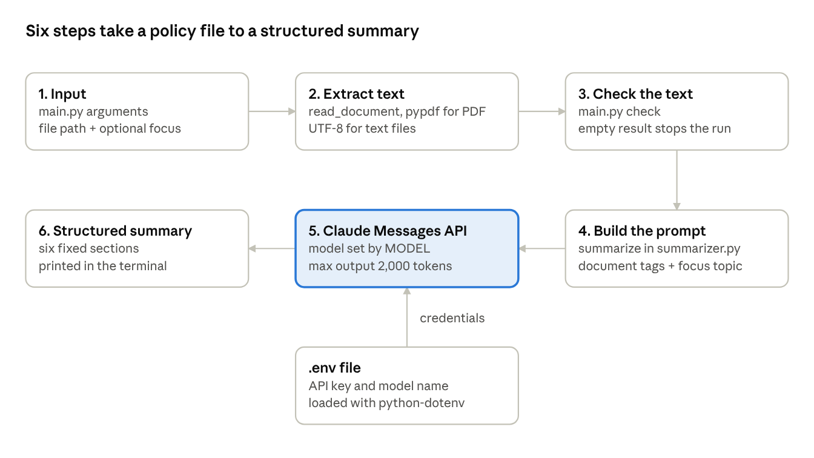
architecture · 6 steps, 1 config file
main.py handles the input, the empty-text check and the output. summarizer.py reads the document, builds the prompt and calls the model, with credentials supplied by .env.
- Configuration. .env holds ANTHROPIC_API_KEY and MODEL, loaded with python-dotenv. Credentials stay out of source control, and the model can be changed without editing code.
- Ingestion (read_document). PDFs are read page by page with pypdf; text files are read as UTF-8.
- Validation (main.py). If no text can be extracted, for example from a scanned PDF, the program stops with a clear message instead of sending an empty document to the model.
- Prompt assembly (summarize). The document is wrapped in <document> tags, and an optional focus topic is appended.
- Inference. A Messages API call sends the system prompt and the user prompt with a maximum output of 2,000 tokens.
- Output. The structured summary is printed to the terminal.
Run it with python main.py policy.pdf or add a focus topic with python main.py policy.pdf "maternity leave".

Prompt Design
- Grounding. The system prompt tells the model to use only information in the document and to say so when something is not stated. This targets hallucination, the main risk when summarising rules and obligations.
- Fixed output schema. Six fixed headings make summaries consistent and easy to scan. Each section can also be checked on its own, which makes evaluation easier.
- Content delimiting. Wrapping the document in tags separates instructions from content, so the model treats the document as data. This reduces prompt-injection risk but does not remove it.
- Focus parameter. The user can steer emphasis at run time without changing the system prompt.
- Plain-English recap. A short closing summary serves readers who need only the gist.

Known Limitations and Mitigations
- Very long documents may exceed the context window. Mitigation: split into chunks, summarise each, then summarise the summaries.
- Scanned PDFs have no text layer. Mitigation: add OCR, for example Tesseract.
- Layout loss. pypdf can extract tables and multi-column pages out of order. Mitigation: use a layout-aware parser for complex documents.
- No source citations. Mitigation: return page or section references with every key point.
- Non-deterministic output. Mitigation: lower the temperature and test against a fixed evaluation set.
- Prompt injection inside documents. Mitigation: treat documents as untrusted, instruct the model to ignore embedded instructions, and validate the output format.
- Not legal or compliance advice. Summaries can omit nuance, so a person should verify anything high-stakes against the source.
- Data privacy. Confidential policies should only be sent through an approved deployment under the organisation’s data-handling terms.

Evaluation Approach
The evaluation is planned and has not been run yet.
- Test set: [N] policies across several domains, each with reference notes listing key obligations, deadlines, penalties and exceptions.
- Metrics: faithfulness (every claim is supported by the source), coverage (key obligations captured), omission rate for deadlines and penalties, format compliance, and a reviewer rating from 1 to 5.
- Method: human review against a written rubric on a sample, plus an LLM judge for scale that is spot-checked by a person. Re-run the set after every prompt or model change to catch regressions.
- Operational tracking: cost and latency per document.
Results: [to be added after the evaluation run].

Roadmap
- Chunked summarisation for long documents.
- Page and section citations on every key point.
- Follow-up question answering over the document, using retrieval.
- Comparison of two policy versions, highlighting what changed.
- OCR support for scanned documents.
- A web interface with logging and feedback capture.
- A human review step for high-stakes outputs.

Product Perspective
- Accuracy versus brevity. Shorter summaries are easier to read but risk dropping exceptions, so the schema reserves a dedicated section for them.
- Automation versus trust. The tool is positioned as a first-pass aid, with citations planned so users can verify claims quickly.
- Cost and latency versus quality. The model is configurable, so a team can trade capability for speed or cost per use case.
- Domain portability. The same pipeline serves HR, insurance, IT security and vendor contracts. Only the system prompt headings change.

Technology Stack
Python 3.10 or later, Anthropic Claude API or Google ADK (TBD) , python-dotenv, pypdf, command-line interface.

